DATASTRUCTURE
CO3-AT-3
NAME: JEEVAN R
REG.NO: 192524007
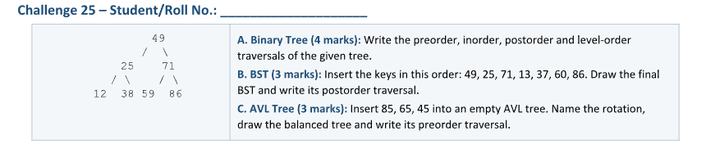
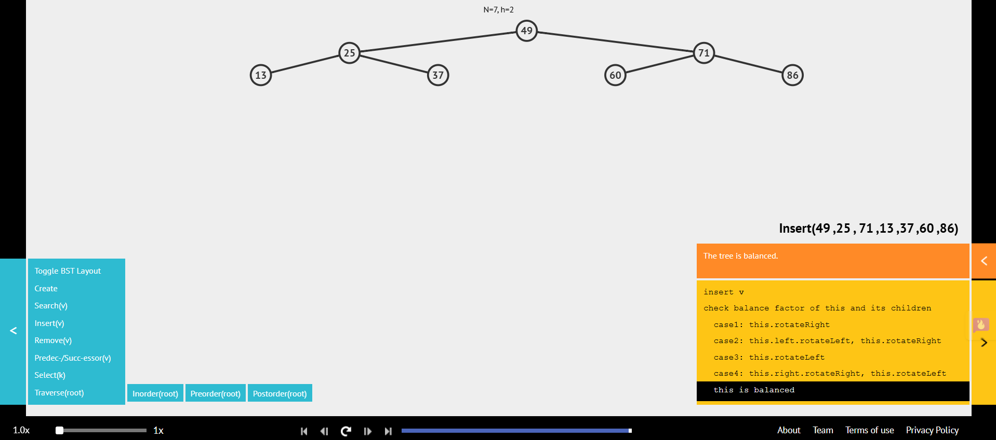
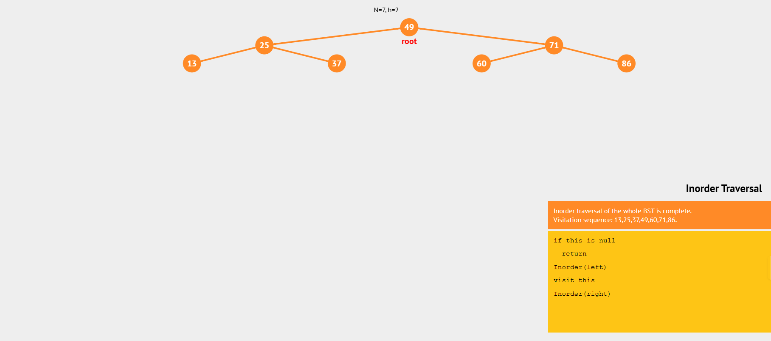
INORDER TRAVERSAL:

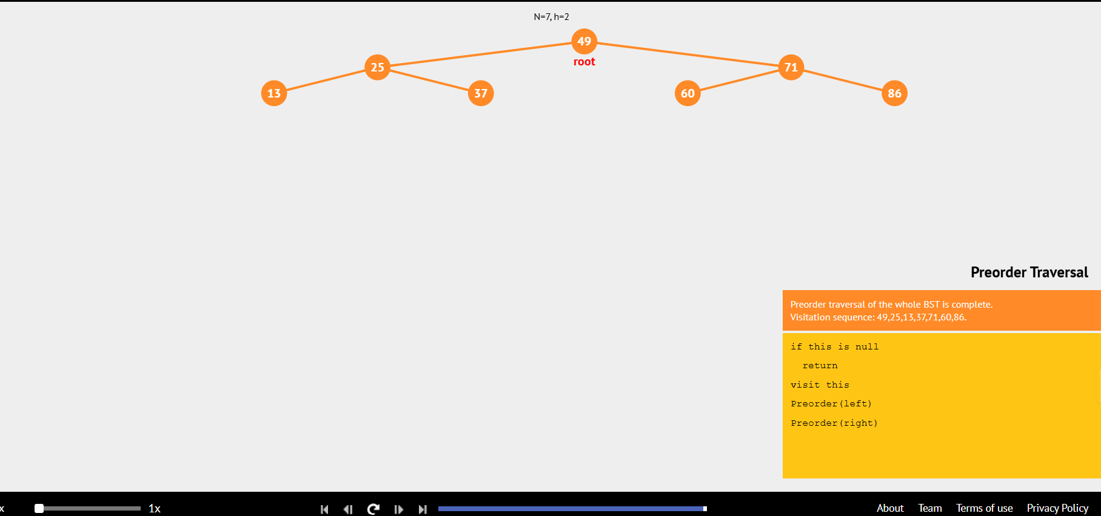
PREORDER TRAVERSAL:
POSTORDER TARVERSAL:
